Project Design Phase
Solution Architecture

Date | 22september2026
Team ID | SWTID-2026-6771
Project Name | AI BlogNest API
Maximum Marks | 4 Marks
Solution Architecture:
AI BlogNest API is a backend solution designed to provide secure and reusable APIs for creating, managing, and processing blog content. It connects users or applications with backend services, database storage, and AI-based content services.
Itsmaingoalsareto:
- Provide reliable REST APIs for creating, reading, updating, and deleting blog posts.
- Define the structure, components, data flow, security, and behaviour of the AI BlogNest API.
- Support AI-assisted blog operations such as content generation and summarization through API services.
- Store user, blog, comments, and related metadata securely and return clear JSON responses.
Example - Solution Architecture Diagram:

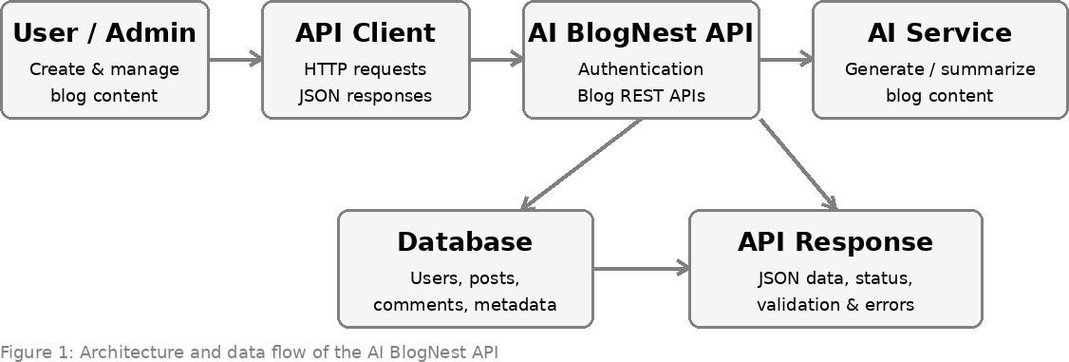

Figure1:ArchitectureanddataflowoftheAIBlogNestAPI

